Sensor integration tutorial w/o LED panels

## Boat prep

1. Test drive the boat.
   1. Set everything to a slow speed.
   2. Make sure the boat can turn and go backwards.
   3. Watch for how low/high the boat sits in the water.

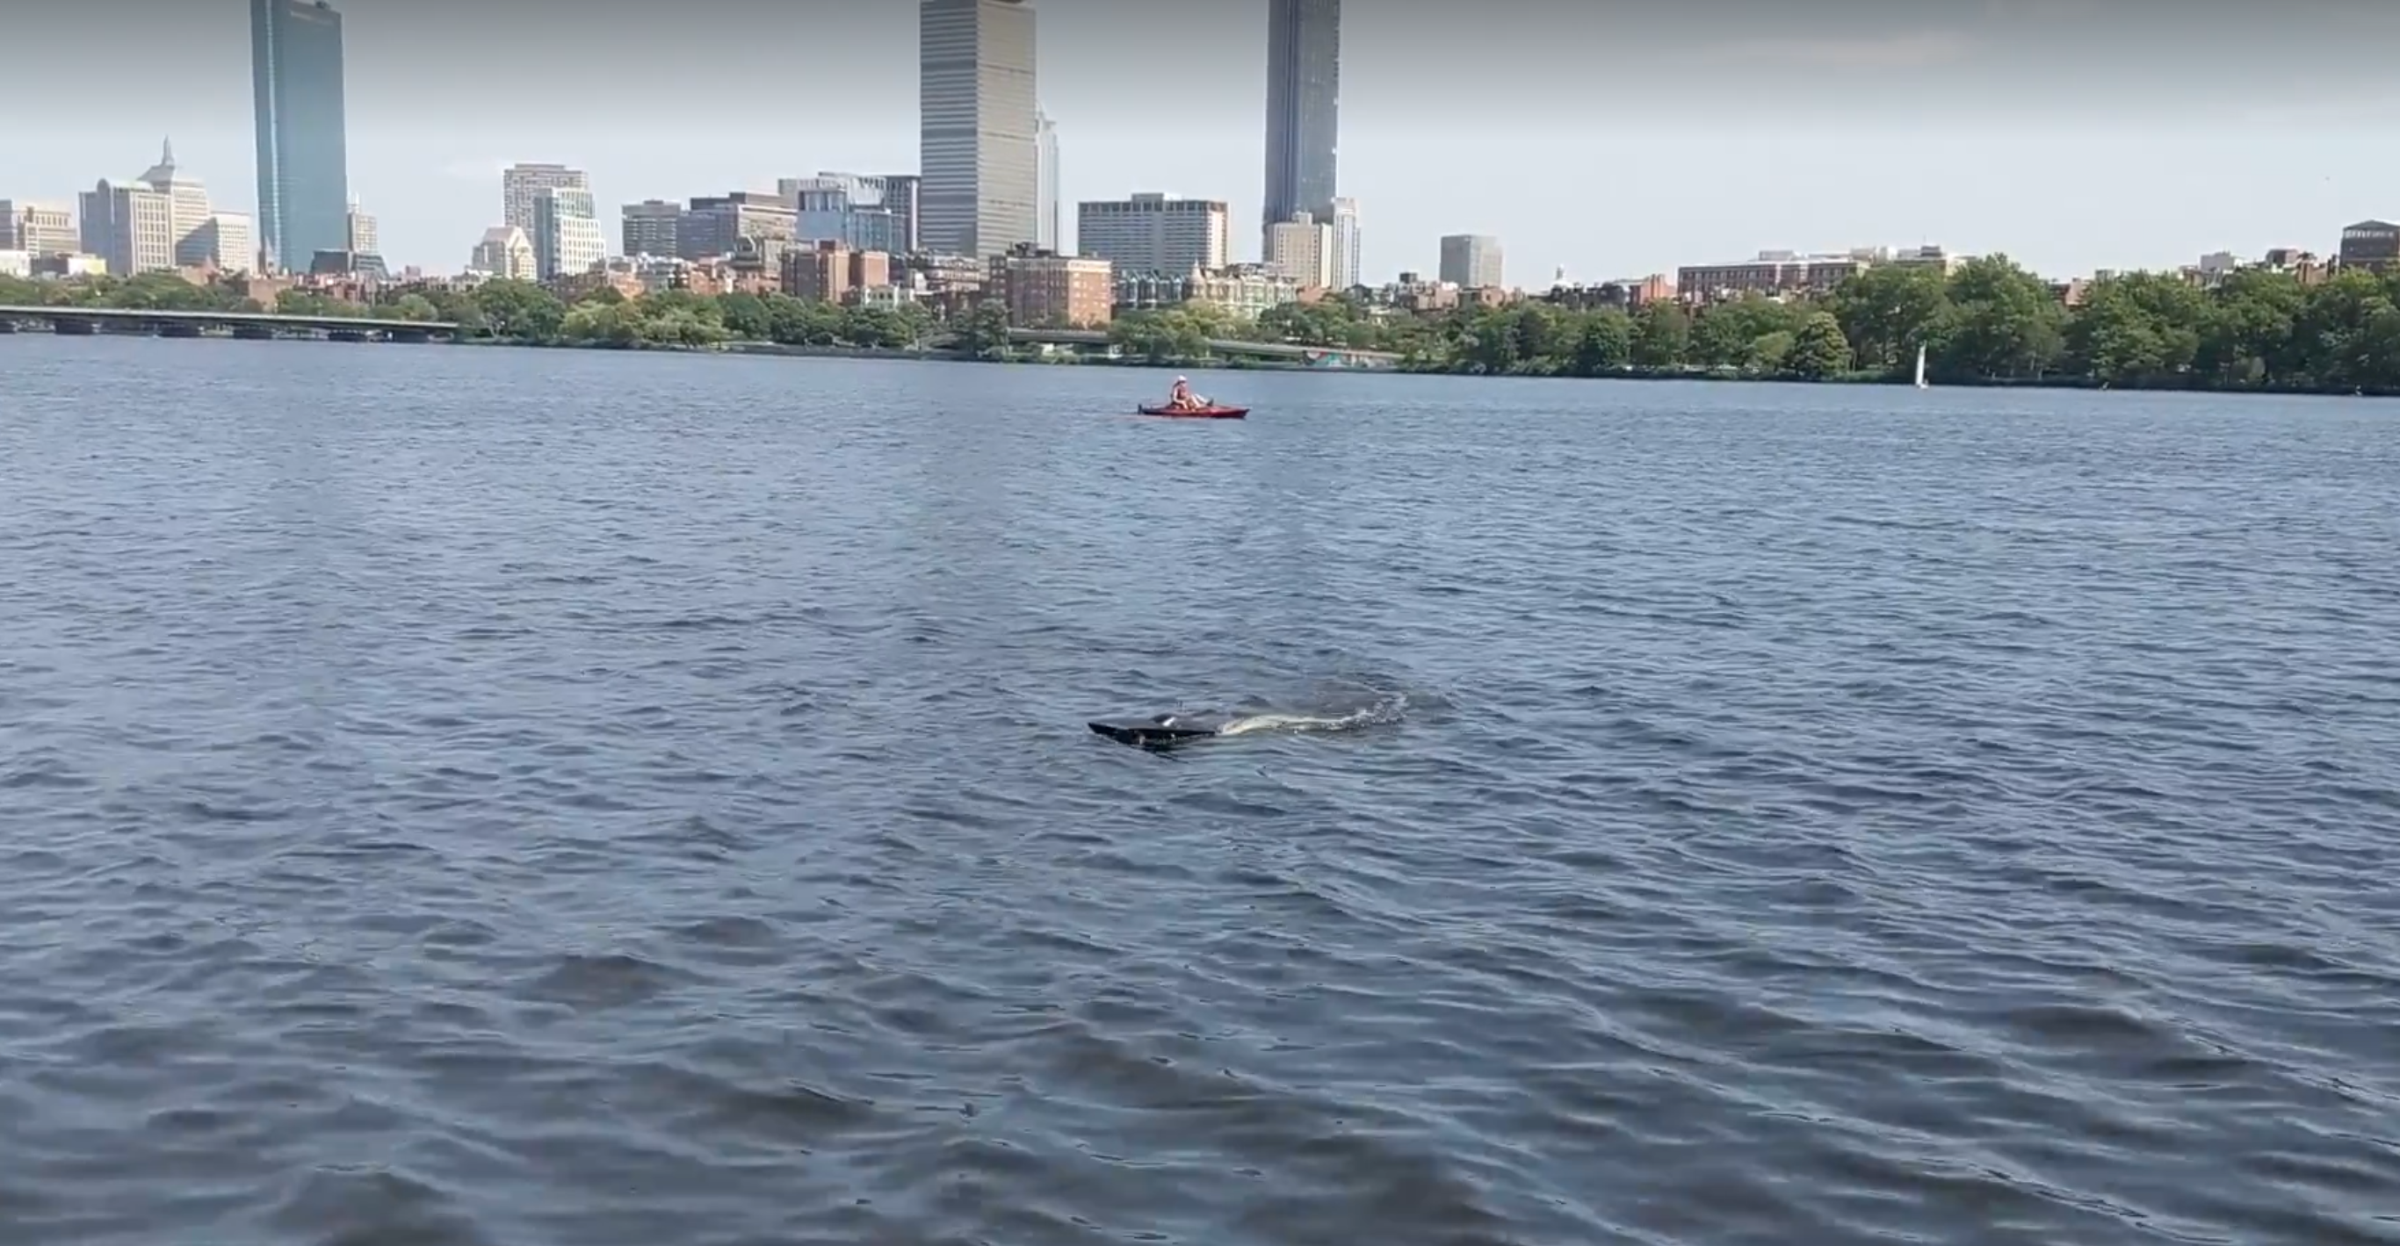 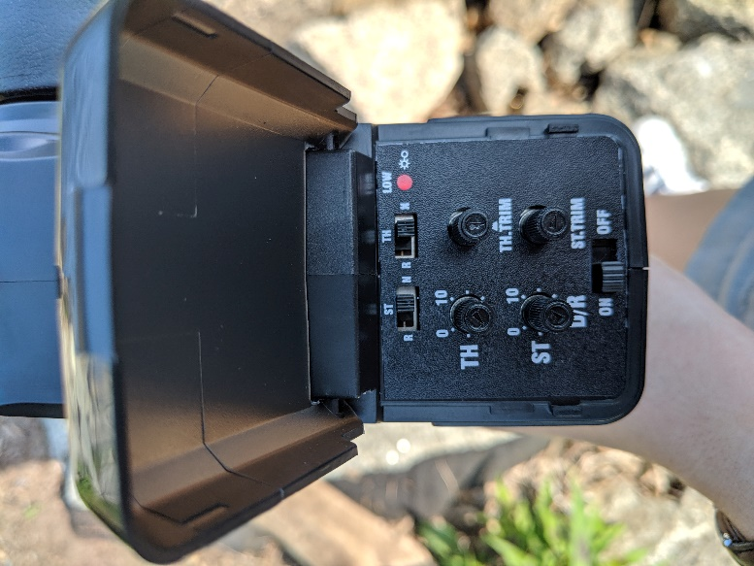

This was a test drive of the boat to see how much of the boat is in the water while it’s driving. The image on the right shows the settings which allowed us to drive at a reasonable speed, turn, and move forwards and backwards.

1. Remove the stickers from the boat. Peel them off, then remove the sticker residue.
   1. The best way we came up with was to use rubbing alcohol. Let the sticker residue soak in the rubbing alcohol for a few minutes before removing the glue goop.

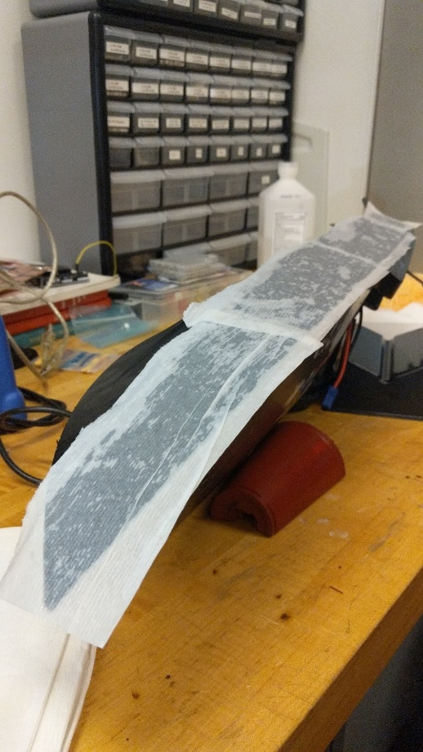

The sticker residue soaking.

# order of installation

1. Scrape out the LED panels.
2. Spray paint the boat.
3. Install the pH sensor (involves drilling, so should be done with nothing extra in the boat).
4. Install the rest of the sensors (easier to thread wires using the holes for the LEDs).
5. Install the LEDs.

# Labeling scheme between sensors

We added tags on the wires of each of the probes close to the header so we can be sure we’re plugging the right sensor into the right port on the Feather. They are color coded as the following:

LEDs 🡪 yellow Conductivity 🡪 green Temperature 🡪 orange

Turbidity 🡪 pink pH 🡪 blue

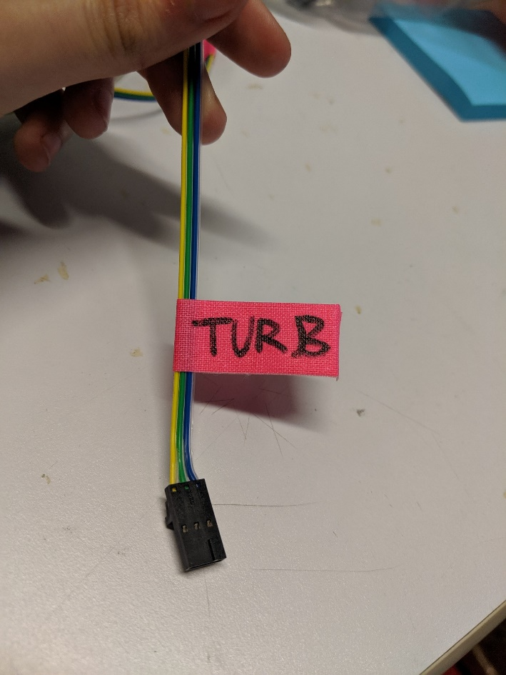

This is what the tag looks like.

## LED strips

### scraping out the panels

1. Using tape, mark out on the boat where you want the LED panels to be (where you want the light to shine through). This can include the top of the boat.
   1. Remember to be mindful that we want the light to be visible from every angle.

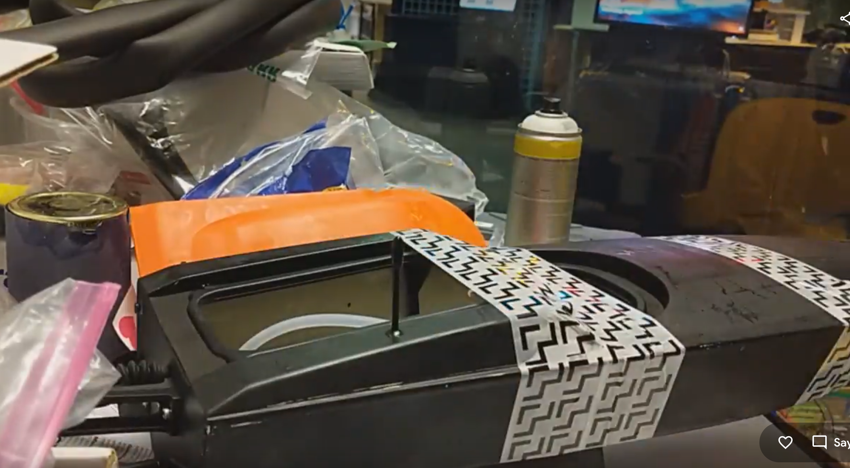

The tape outlines where we want the light to come through.

1. Cover the surface in paper towel soaked with rubbing alcohol. You’ll need to continuously douse the paper towel as the alcohol evaporates.

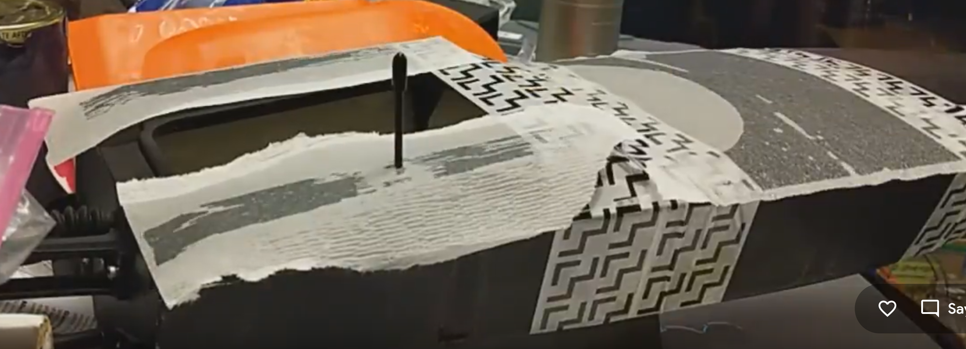

Starting with the stop of the boat, we are soaking the surface with rubbing alcohol.

1. Using a flathead screwdriver, scrape away the paint. You’ll probably have to repeat steps 2-3 a few times before all the paint is gone.
   1. For the top of the boat, sanding might work better than scraping.

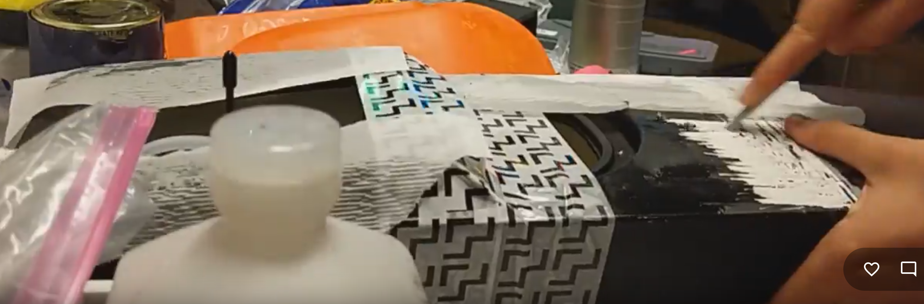

Beginning to scrape off the paint from the front of the boat.

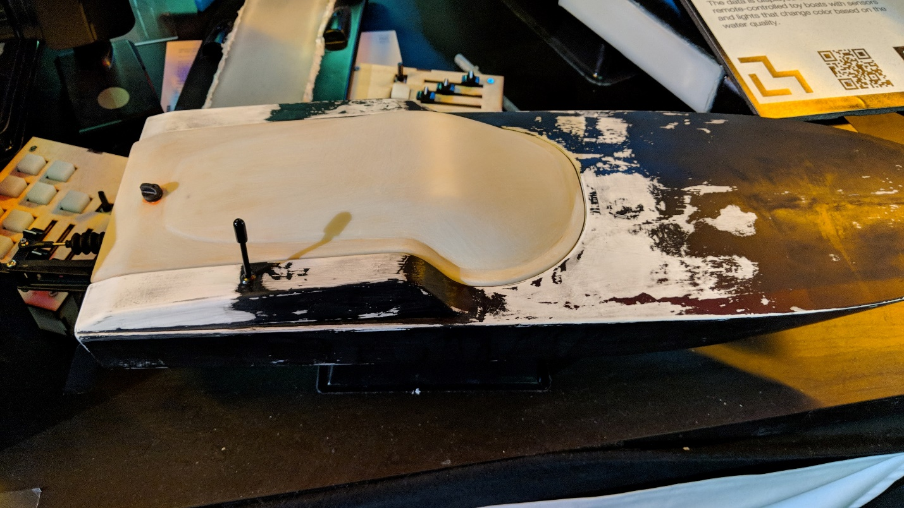

The top of the boat, after the paint had been sanded off.

### led strip set-up

1. Cut the LED strips to the correct lengths and rewire them.
   1. Be careful when doing this as if rewired incorrectly all the LEDs will burn out and the strip will be ruined!

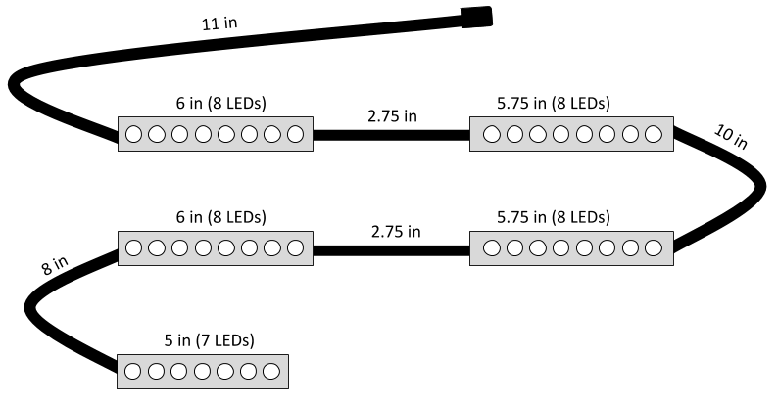

These are the LED strip lengths and connecting wires lengths you should follow.

1. Test the strip!
   1. Make sure to have a battery connected.
   2. Check for any loose strands of wire.
   3. Add extra solder if it seems the current isn’t reaching some of the LEDs.
   4. Try reconnecting to the other side of the strip.
   5. Make sure in the code that the number of pixels is correct.
2. Silicone glue the ends of the strips.

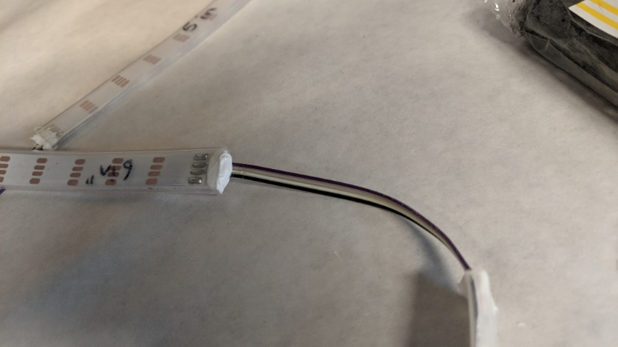

A sealed LED strip.

## SPRAY-PAINTING

1. Sand the space where turbidity will be glued.
   1. Sand the boat until there is no paint where there will be epoxy. Wipe off any dust that accumulates.

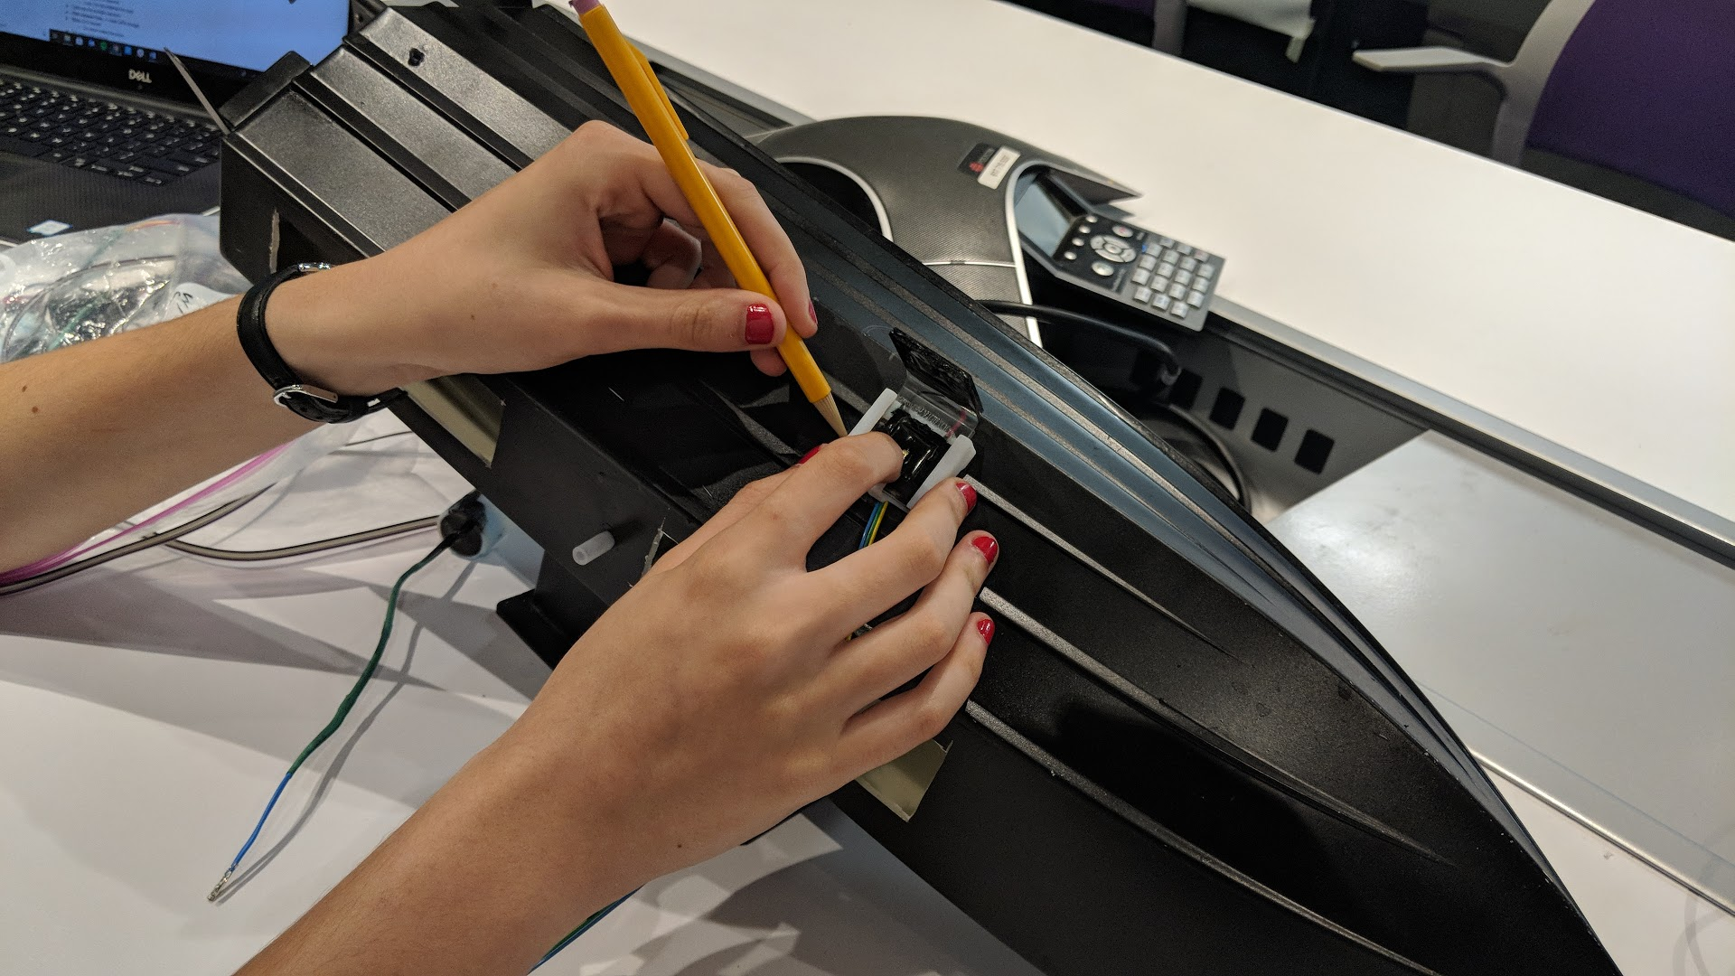

We traced the outside of the turbidity holder in pencil first, then outlined that sketch with blue tape for sanding.

1. Sand the space where conductivity will be glued.
   1. Sand the boat until there is no paint where there will be epoxy. Wipe off any dust that accumulates.

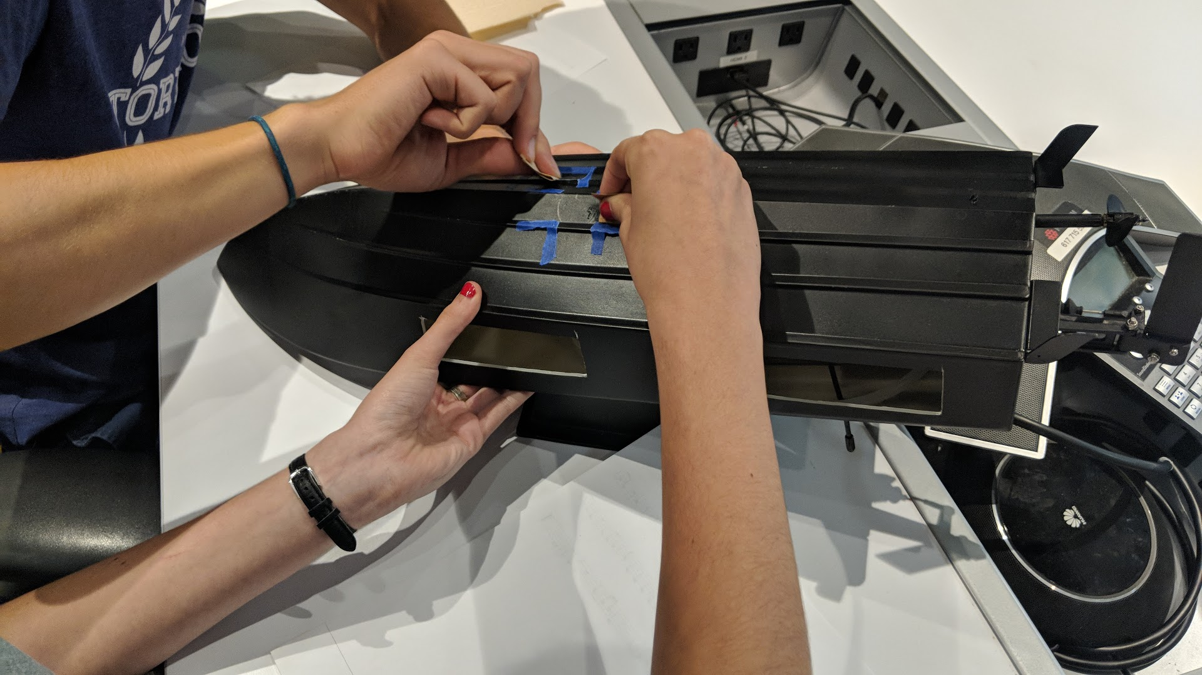 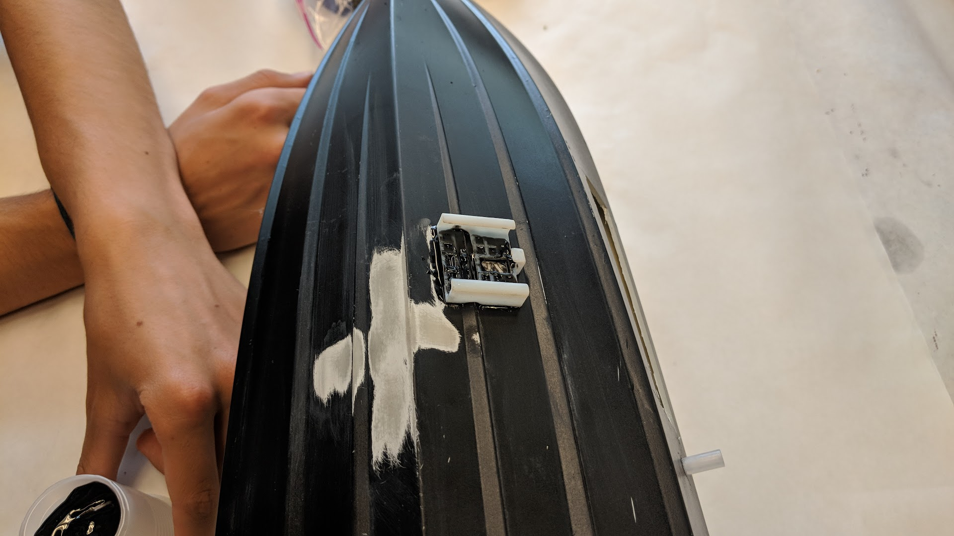

We traced the outside of the conductivity holder in pencil first, then outlined that sketch with blue tape for sanding.

1. Sand the entire boat with low grit sandpaper until it’s smooth to the touch.
2. Tape up the LED panels, motor, sanded parts for the sensors, etc (anything that shouldn’t be spray painted). You can also use plastic bags to wrap up the larger pieces.

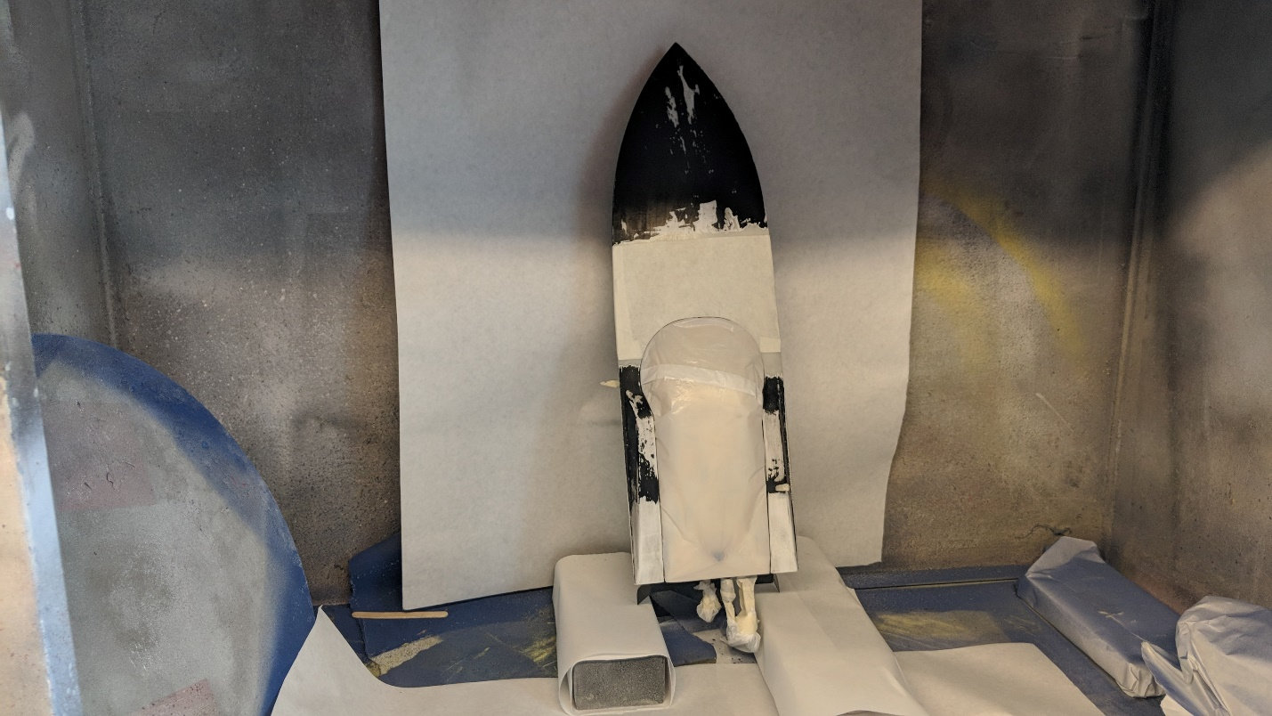

The boat all taped/wrapped up and ready to be spray painted.

1. Now you can spray paint. Remember to test the spray to make sure it’s normal. Try to keep the sprayer about 6 inches away from the surface.

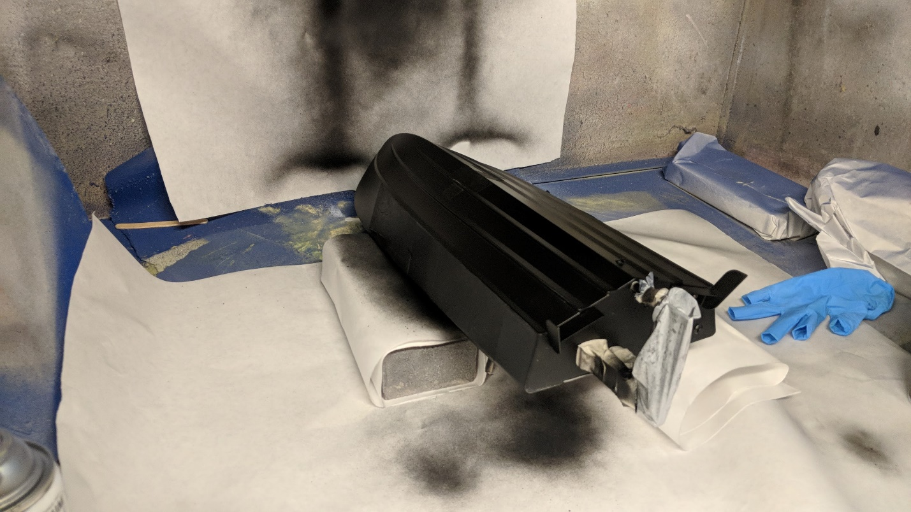

The boat after it’s been spray painted. You can see the outline of the taped-up parts.

1. Spray a protective coat on top of the paint.

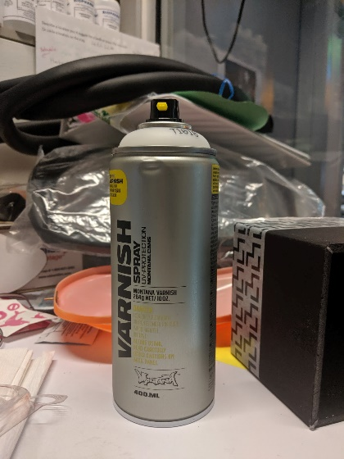

This is the varnish we used.

1. Peel off all the tape!

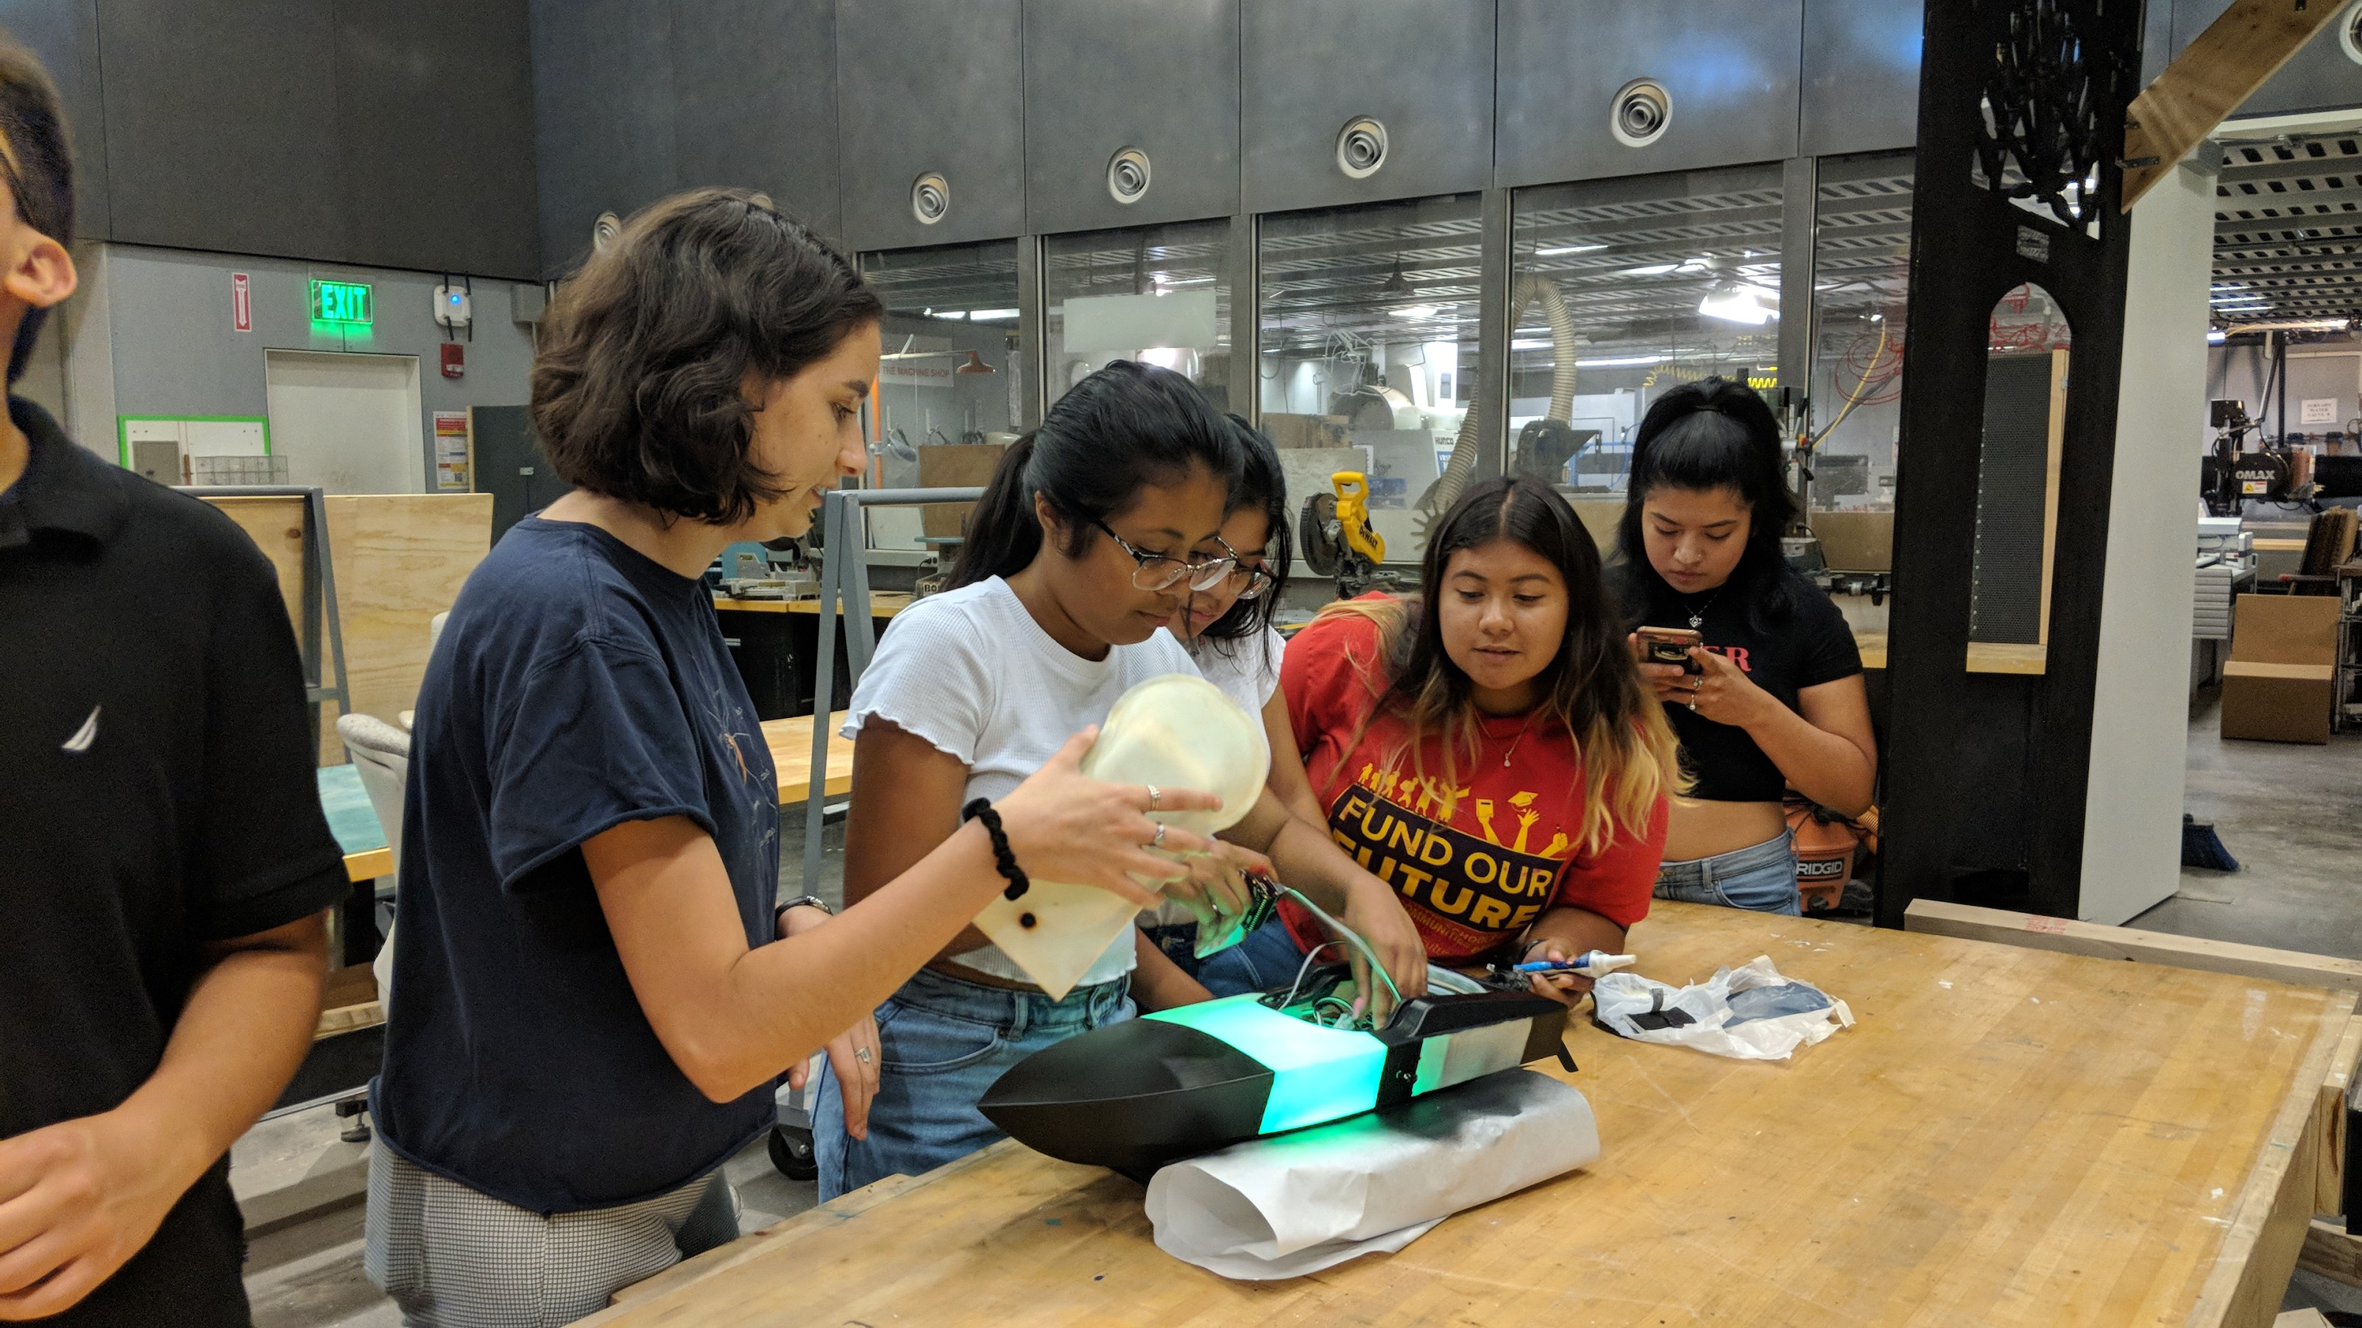

Testing the LED panels after removing the tape.

## pH

1. Melt a hole for the pH wire in the top of the boat.
   1. You’ll need to melt a small path all the way to the edge of the top, and then wedge the wire in by gently twisting the plastic open.
   2. After the wire is in and at the ideal length, sand the plastic around the hole, and use regular epoxy and silicone glue to seal it shut.

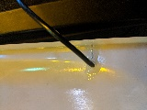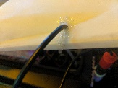

The sealed hole for the pH wire.

1. Wrap foam tape around the probe to make it a little thicker and have more friction.
2. Cut a small length of rubber tubing and pull it over where the tape is, and add o-rings on either side.

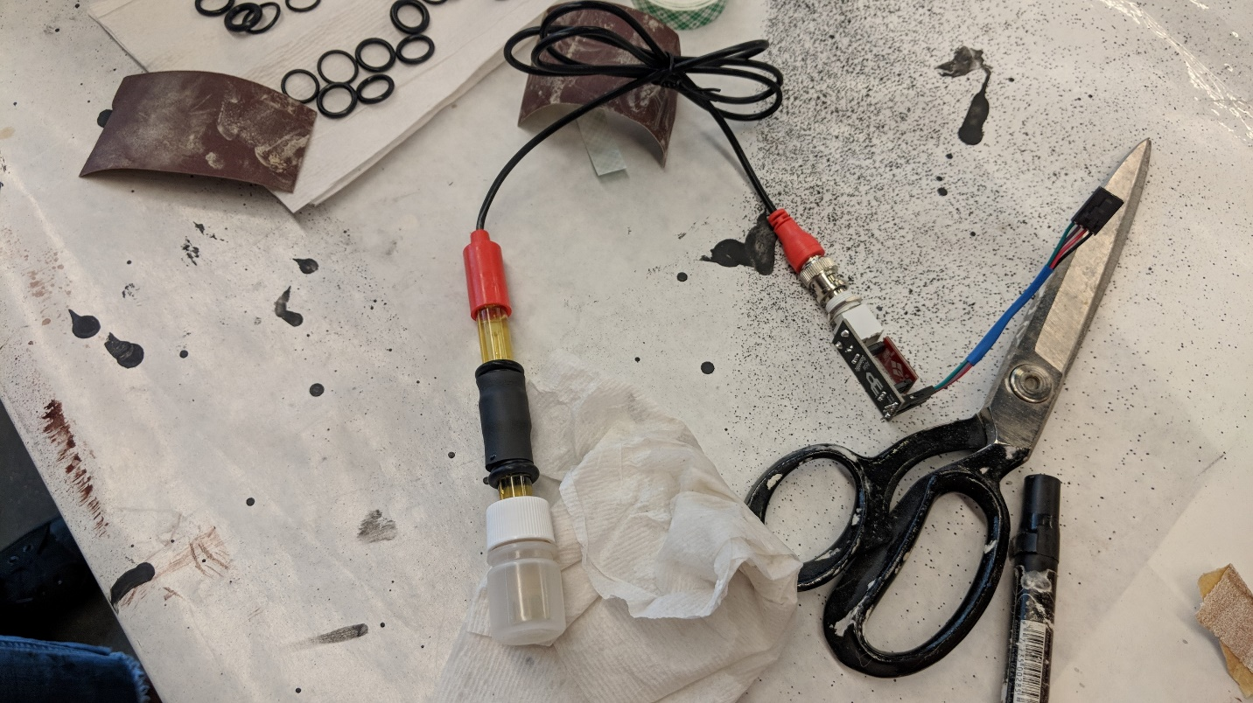

The o-rings prevent the rubber tubing from sliding up and down the pH probe.

1. Put the clamp around the probe.
2. Mark on the boat where the holes for the screws will be.
3. Drill 2 holes.
   1. We used a 29 drill bit.
4. Screw the clamp onto the boat.
   1. Order on screws: clamp 🡪 foam o-ring 🡪 boat 🡪 foam o-ring 🡪 nut (look at the images below)
   2. Use Loctite!

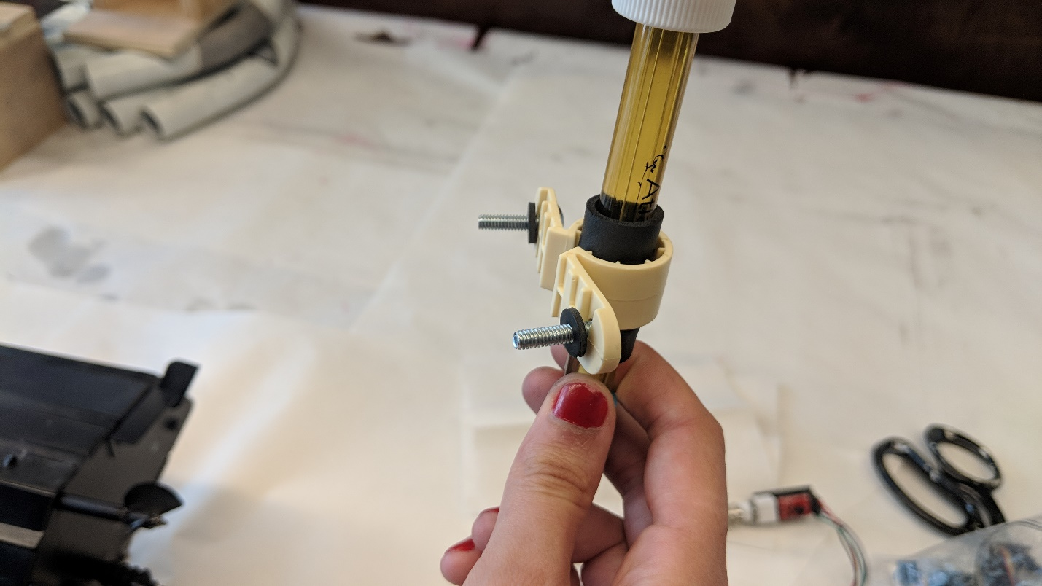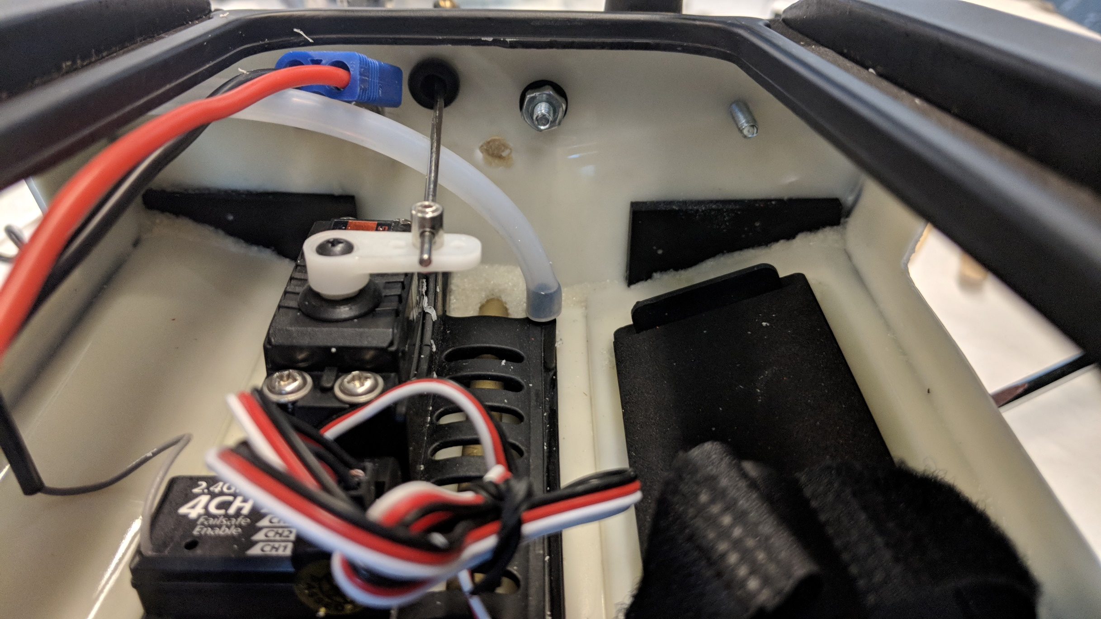

These images show how to screw on the pH clamp.

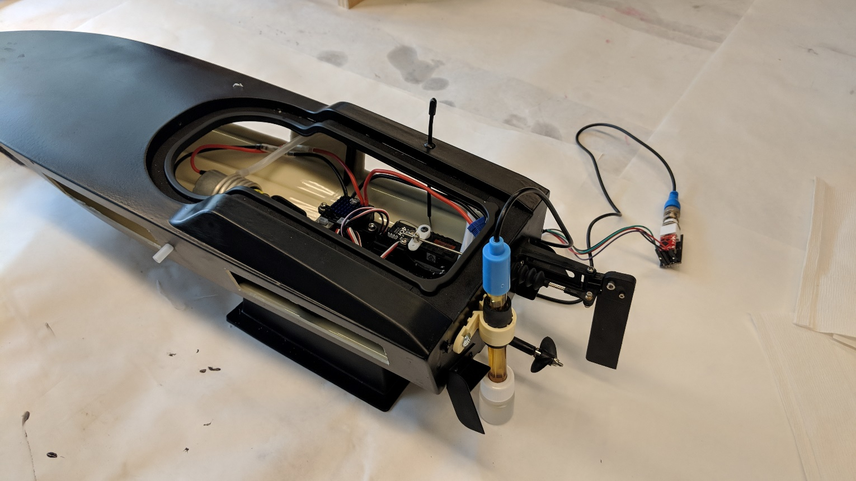

This is the pH probe after it’s been properly secured with screws and Loctite.

## turbidity

1. 3-D print the boat attachment part for the 1/16-inch-thick turbidity sensor.
2. Epoxy the part onto the boat.
   1. Use the plastic-plastic epoxy.

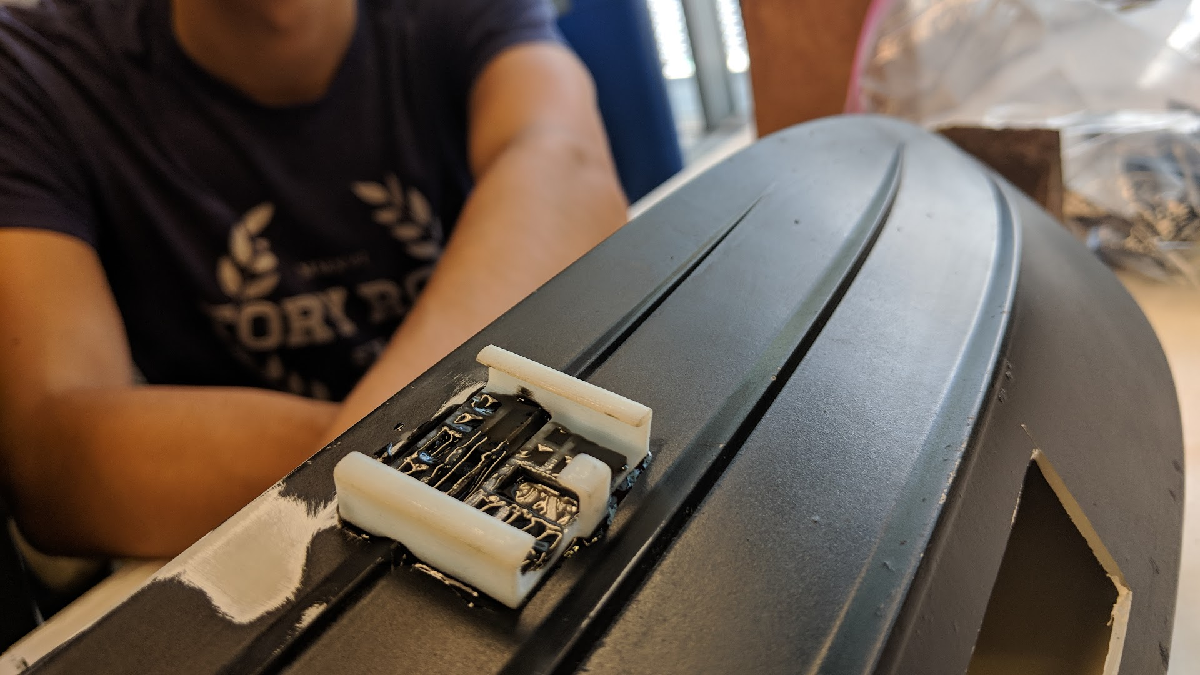

Our epoxied turbidity boat attachment.

1. Melt a hole for the wires using the soldering iron from the outside of the boat.
   1. Make the hole just large enough for the wires to get through.

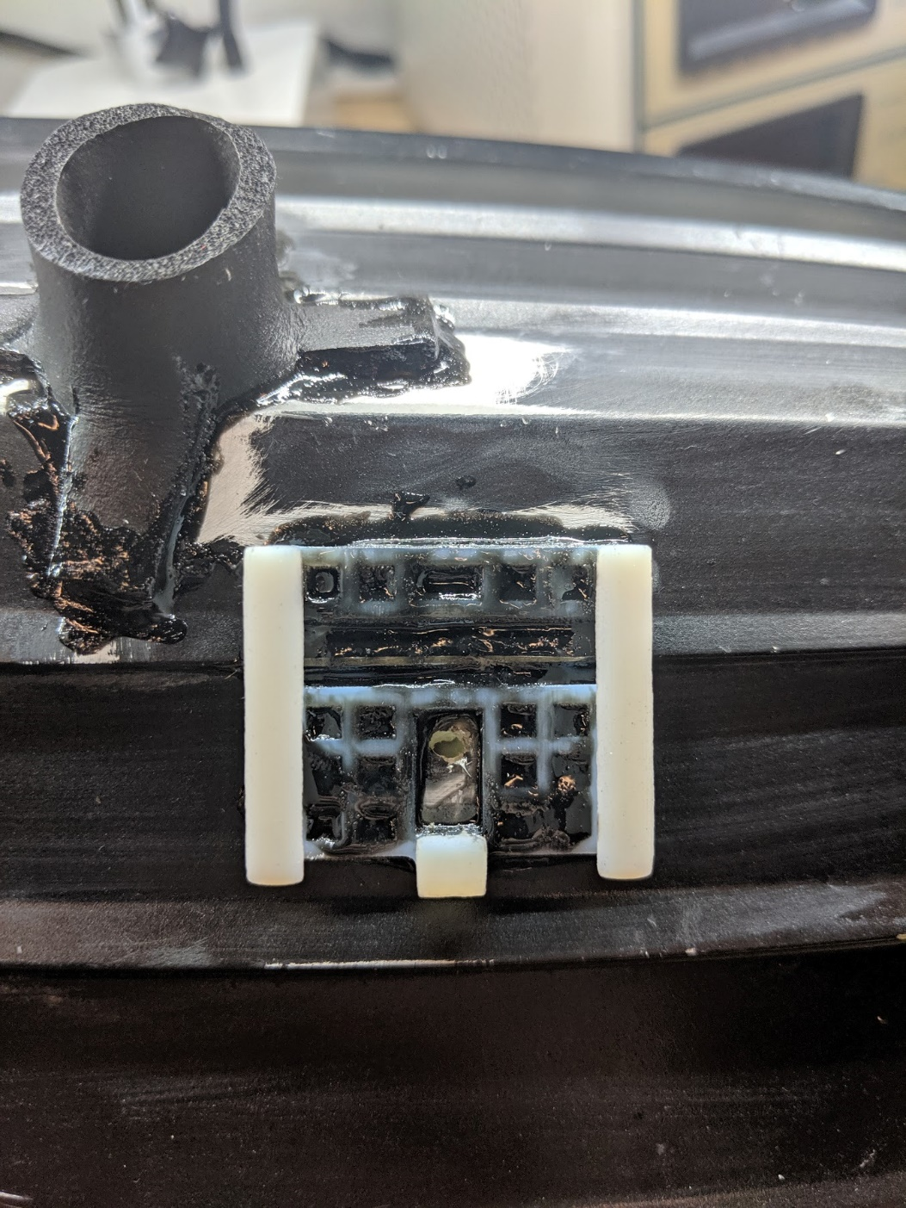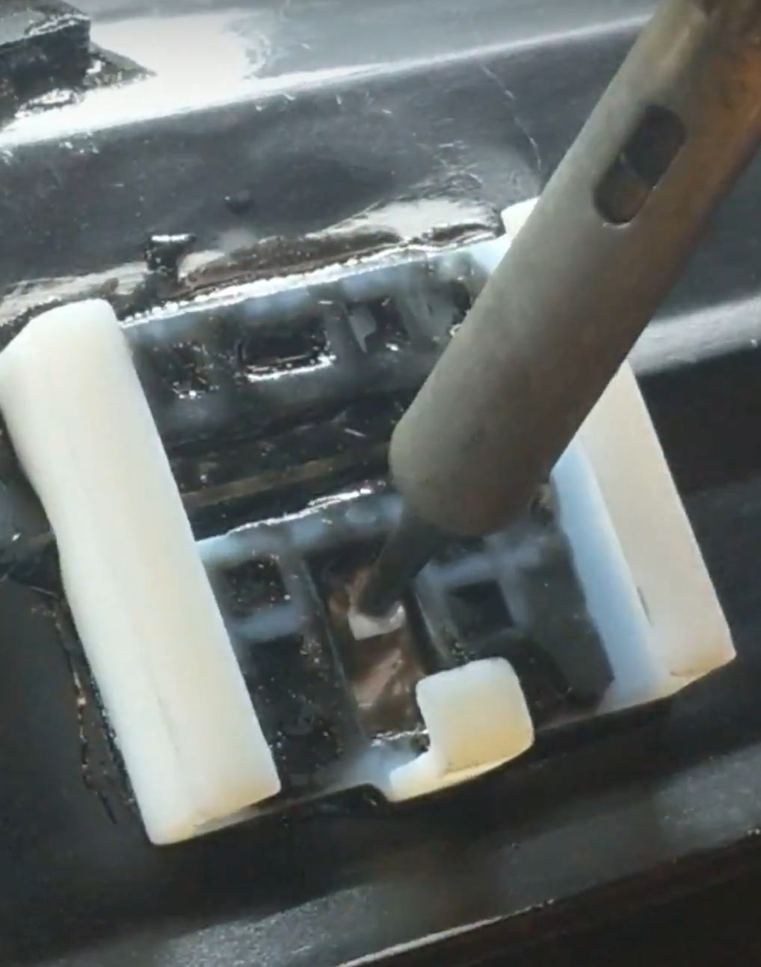

The melted hole for the turbidity sensor, and the process of melting it.

1. Cut out a piece of foam board to slot into the boat attachment while there is no sensor in it to help protect it.
2. Attach the header on the end of the wires once the sensor is installed.
3. Use silicone glue to seal the wires in the hole.
   1. At this step you can reinforce the wires of the turbidity sensor using plastic-plastic epoxy on top of the heat shrink.

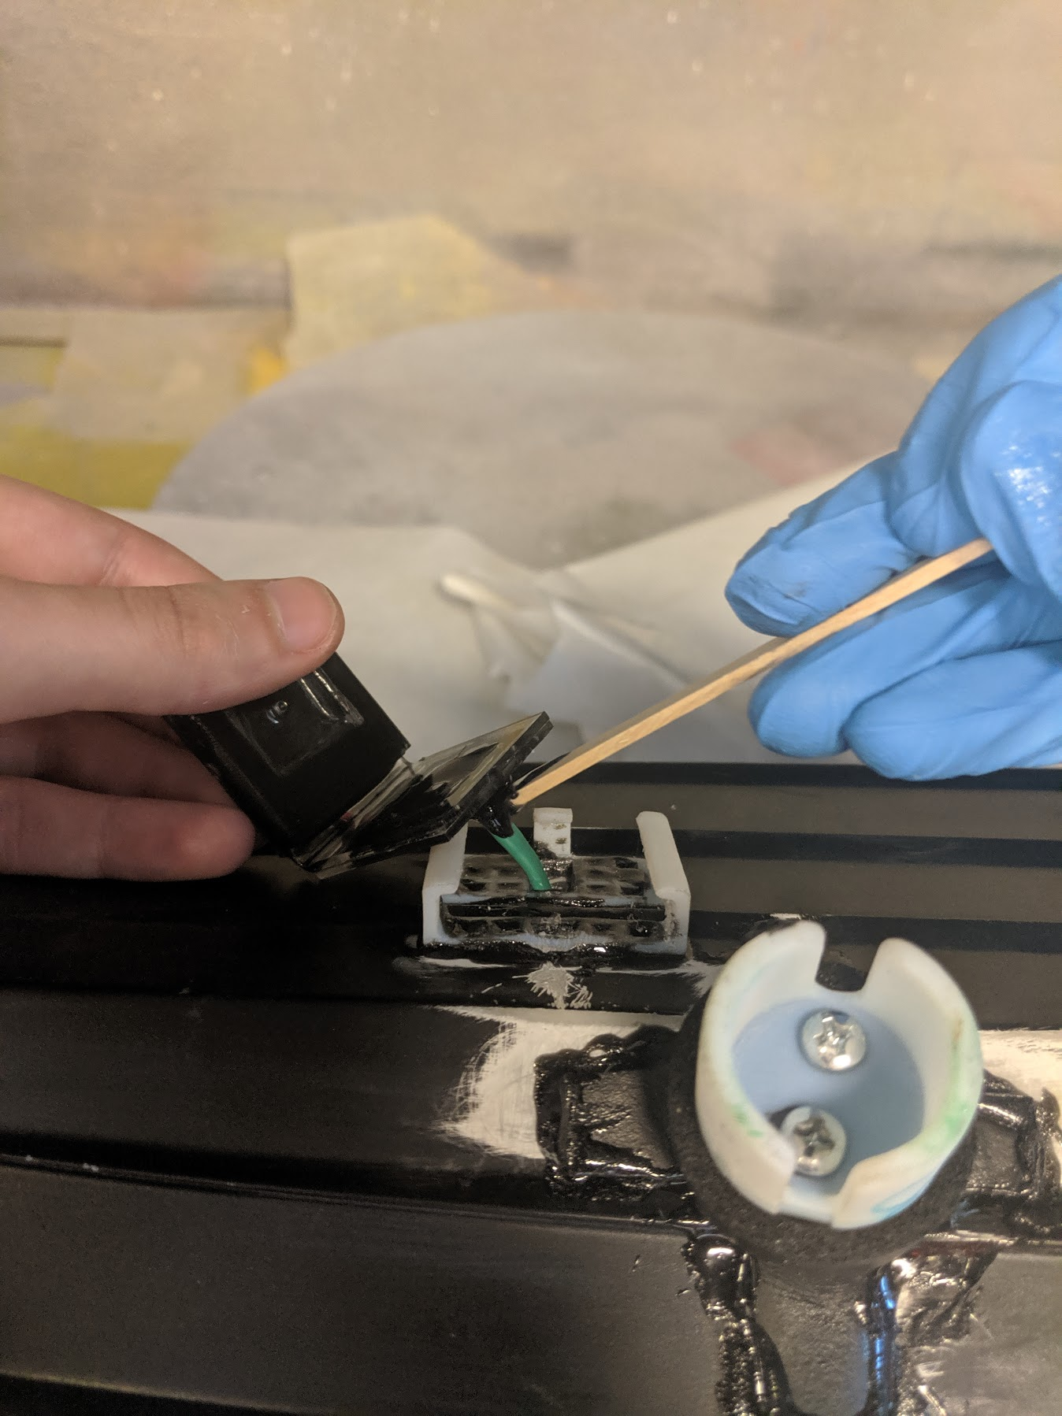

Applying epoxy to the turbidity wires to strengthen them before we seal them in the hole.

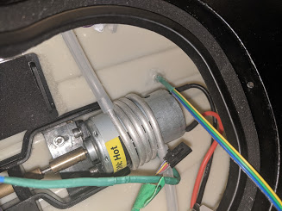

The sealed hole for the turbidity sensor.

## conductivity

1. Cut the probe holder out of the rubber tubing using the template.

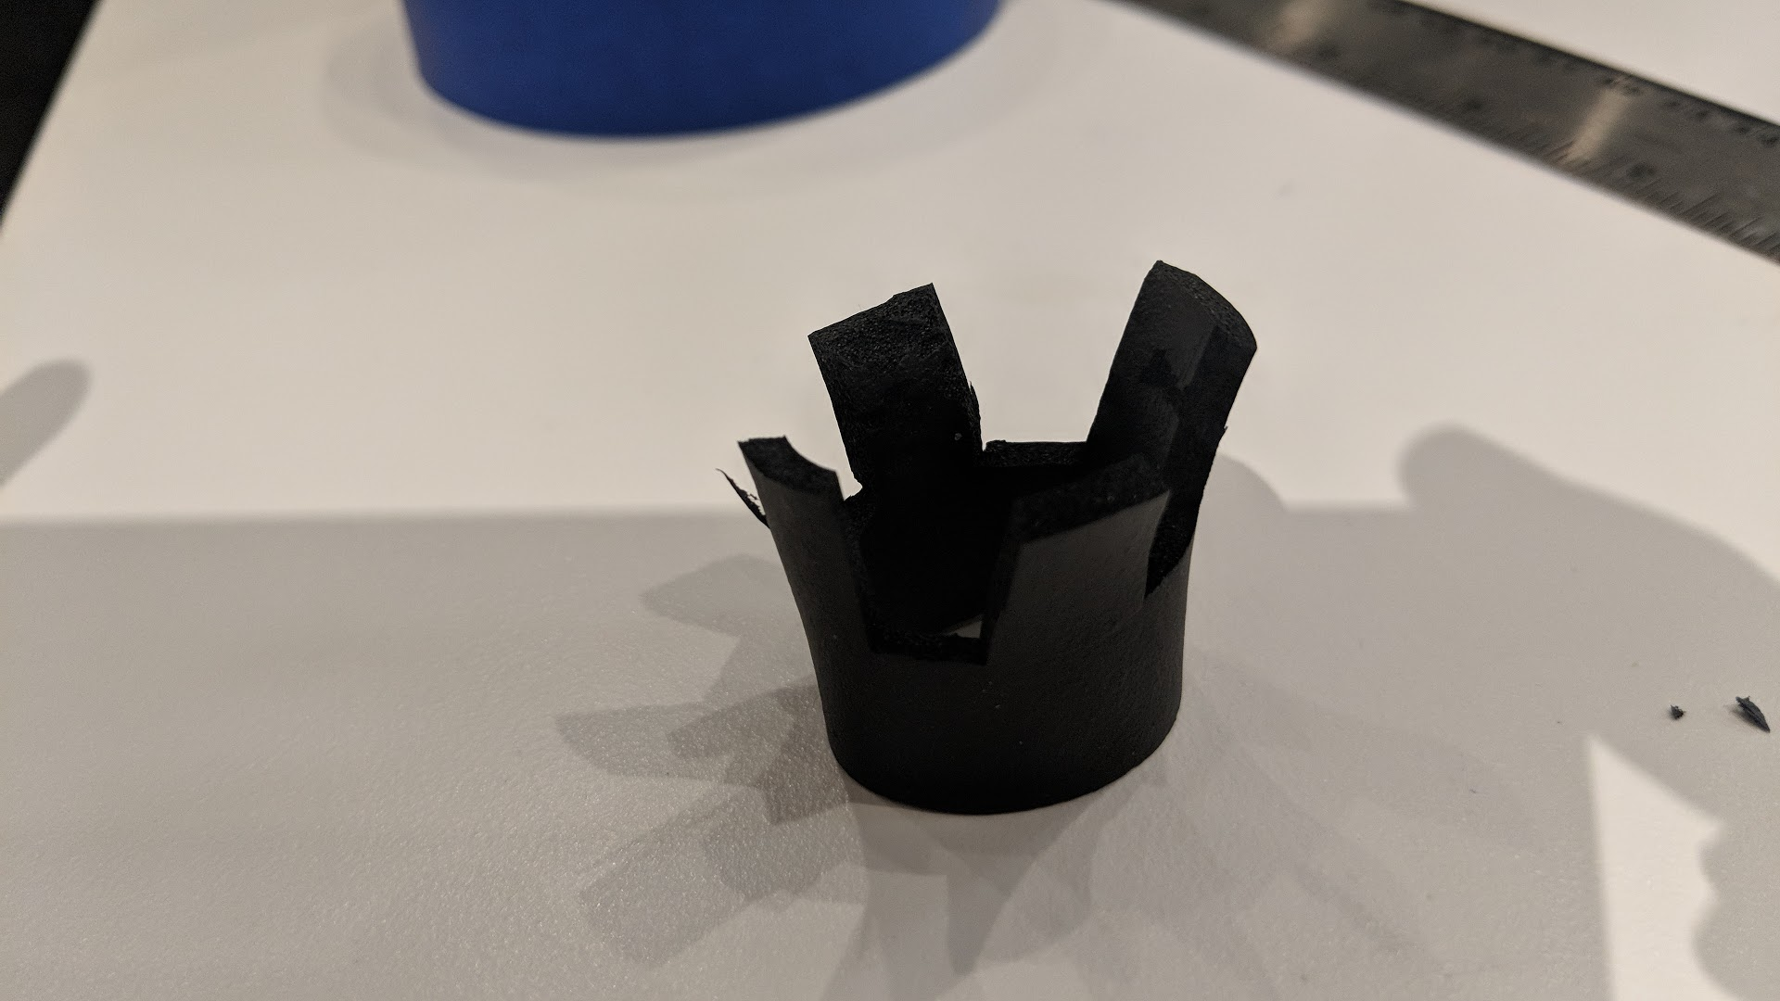

This is the tubing after it’s been cut according to the template.

1. ‘Sand’ the rubber so that the foam interior is exposed; the epoxy doesn’t adhere well to the outside coating.
2. Epoxy the rubber onto the boat. Hold the part manually for a few minutes, then use tape to hold it in place while it cures.

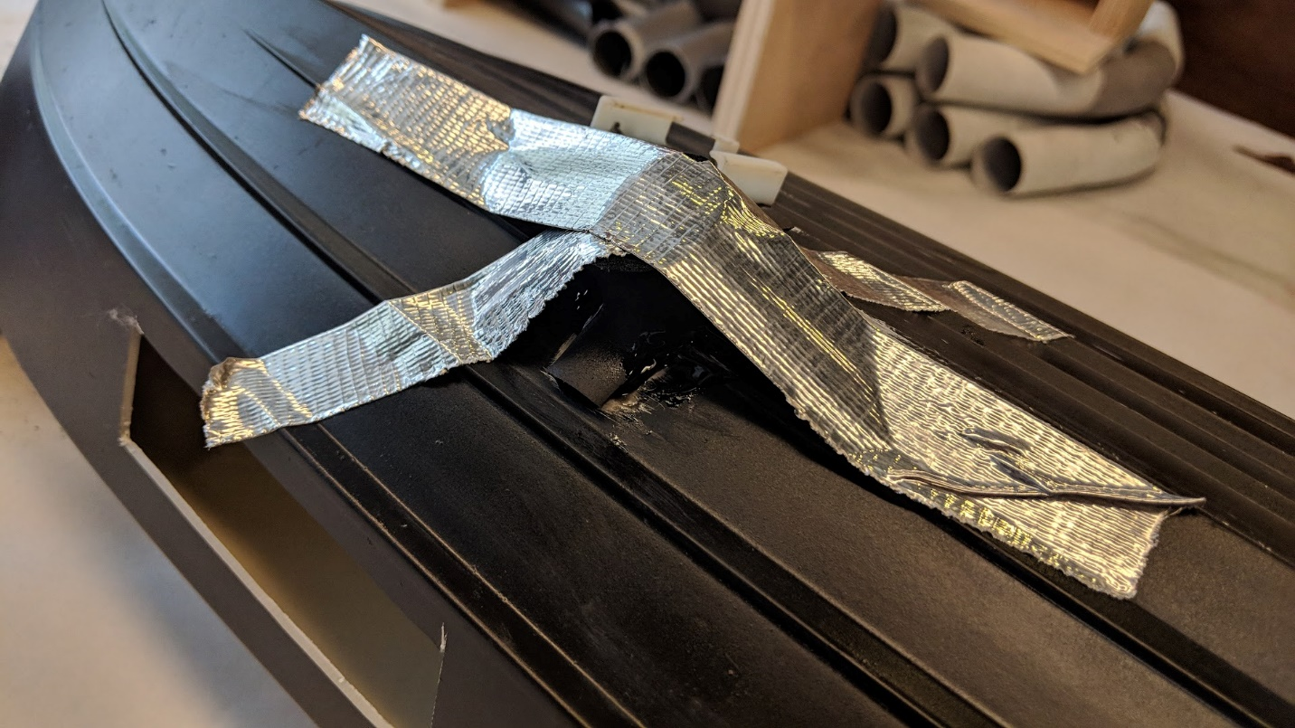

This is how we taped down the tubing to let the epoxy cure for a while.

1. Melt a hole for the wires using the soldering iron from the outside of the boat.
   1. Make the hole just large enough for the wires to get through.

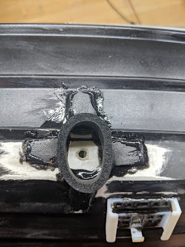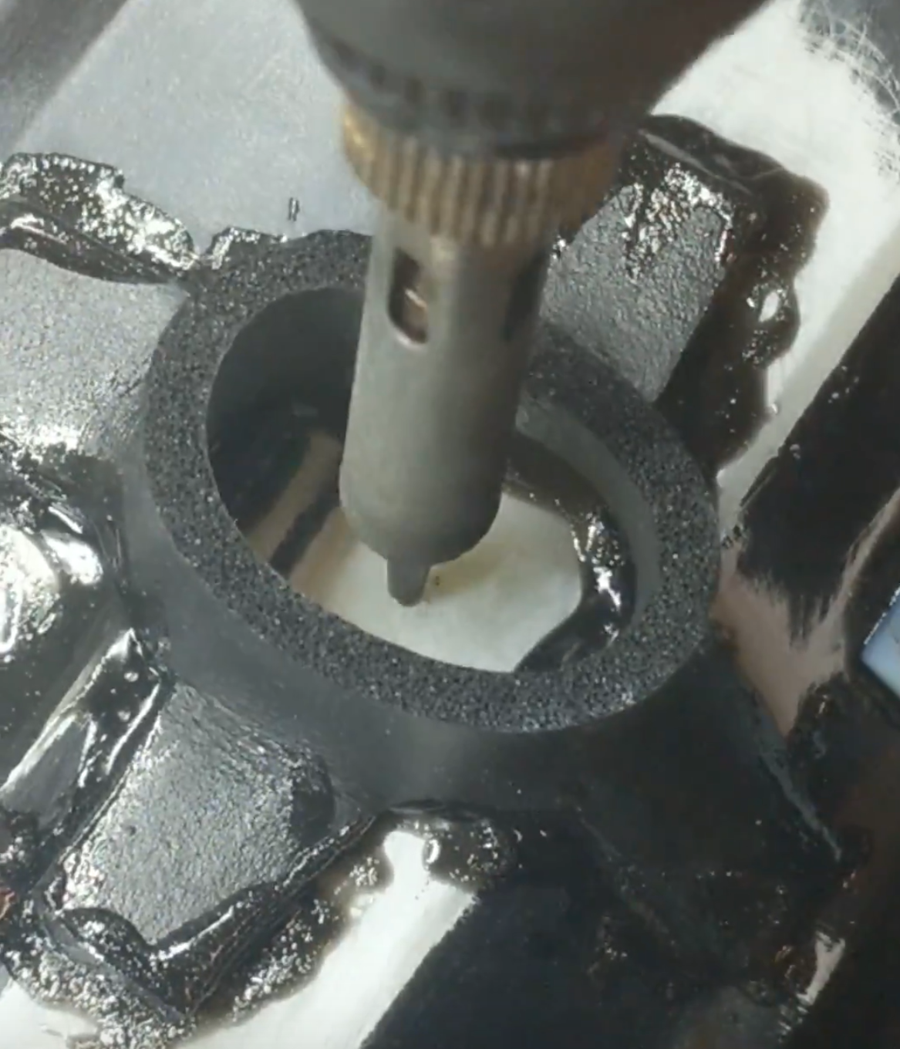

The melted hole for the conductivity sensor, and the process of melting it.

1. Remove the motor from the boat.
   1. This requires loosening the set screws on the motor shaft, and unscrewing the motor mount from the bottom of the boat.

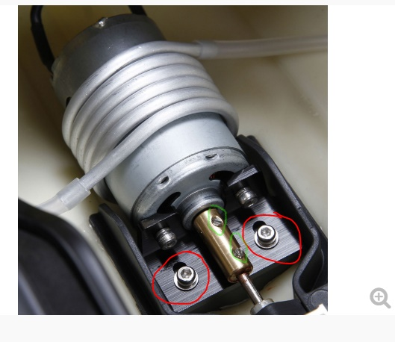

The set screws are circled in green, and the motor mount screws are circled in red.

1. Thread the sensor wires through the hole.
2. Attach the header on the end of the wires.
3. Use silicone glue to seal the wires in the hole.
4. Re-attach the motor mount to the boat.

## temperature

1. Melt a hole for the wires using the soldering iron. Start from inside the boat so you can be sure not to hit any other parts.
   1. Make the hole just large enough for the wires to get through.

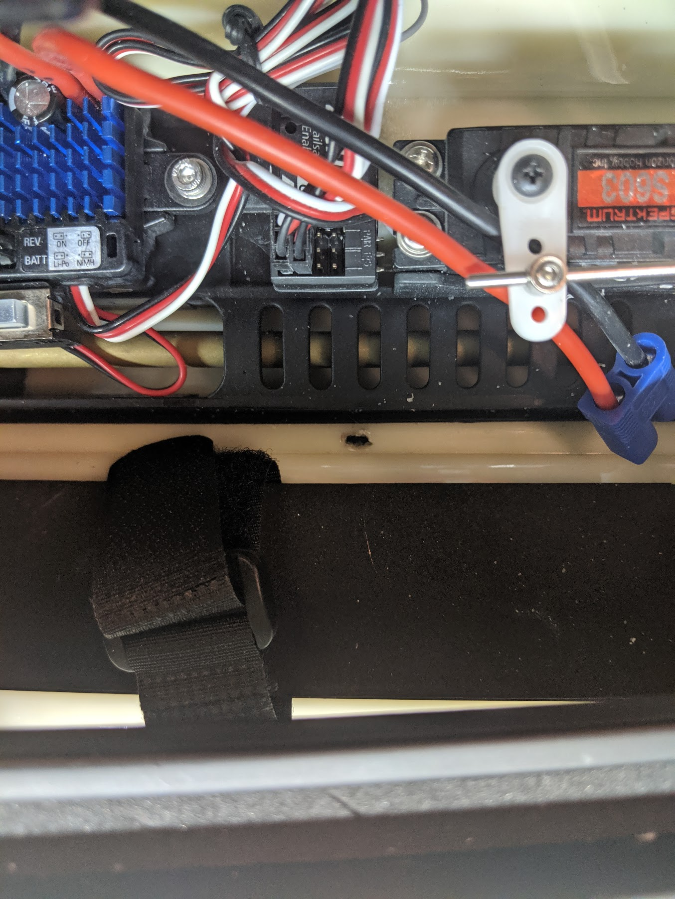

The melted hole for the temperature sensor.

1. Attach the header on the end of the wires once the sensor is installed.
2. Use silicone glue to seal the wires in the hole.

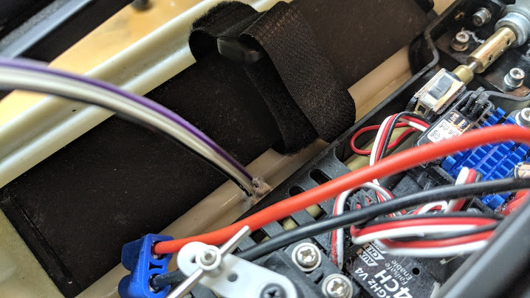

The sealed hole for the temperature sensor.